
SECURE PASSWORD STRENGTH EVALUATION USING PATTERN MATCHING ALGORITHMS
A CAPSTONE PROJECT REPORT

A Capstone Project Report submitted in partial fulfilment of the requirements for the Course of

CSA0603 – Design and Analysis of Algorithms

to the award of the degree of

BACHELOR OF ENGINEERING / BACHELOR OF TECHNOLOGY
IN
COMPUTER SCIENCE AND ENGINEERING
Submitted by
V. Bala Siva Prasad Reddy (192424316)
Under the Supervision of
Dr. P. Solainayagi
SIMATS ENGINEERING
Saveetha Institute of Medical and Technical Sciences
Chennai – 602105
SEPTEMBER 2026

SIMATS ENGINEERING
Saveetha Institute of Medical and Technical Sciences
Chennai – 602105
BONAFIDE CERTIFICATE
This is to certify that the Capstone Project entitled “Secure Password Strength Evaluation using Pattern Matching Algorithms – Module 2: Password Pattern Analysis” has been carried out by V. Bala Siva Prasad Reddy (Reg. No. 192424316) under the supervision of Dr. P. Solainayagi and is submitted in partial fulfilment of the requirements for the current semester of the B.Tech Computer Science and Engineering program at Saveetha Institute of Medical and Technical Sciences, Chennai.

COURSE COORDINATOR  Dr. F. Mary Harin Fernandez,  Professor  Department of Computer Science and Engineering  SIMATS Engineering,  SIMATS, Chennai – 602105. | COURSE FACULTY  Dr. P. Solainayagi,  Professor  Department of Computer Science and Engineering  SIMATS Engineering,  SIMATS, Chennai – 602105.
Submitted for the Project Work Viva-Voce held on ____________________

INTERNAL EXAMINER EXTERNAL EXAMINER

SIMATS ENGINEERING
Saveetha Institute of Medical and Technical Sciences
Chennai – 602105
DECLARATION
I, V. Bala Siva Prasad Reddy, of the Department of Computer Science and Engineering, SIMATS Engineering, Saveetha Institute of Medical and Technical Sciences, Chennai, hereby declare that the Capstone Project Work entitled “Secure Password Strength Evaluation using Pattern Matching Algorithms –Password Pattern Analysis” is the result of my own bonafide effort. To the best of my knowledge, the work presented herein is original, accurate, and has been carried out in accordance with the principles of engineering ethics and academic integrity. All sources, references, data, and other materials used in the project have been appropriately acknowledged. I further declare that the data, results, analysis, and findings presented in this report have not been fabricated, falsified, or manipulated. Any external tools, software, datasets, computational resources, or AI-assisted tools used during the project have been appropriately disclosed. I confirm that all applicable ethical, academic, institutional, and professional requirements have been duly followed throughout the planning, execution, analysis, and documentation of the project.

Place: Chennai
Date:

Signature of the Student
V. Bala Siva Prasad Reddy

SIMATS ENGINEERING
Saveetha Institute of Medical and Technical Sciences
Chennai – 602105

Individual Contribution Statement

Student Name / Register No. | Specific Responsibilities | Design & Development Contribution | Testing & Analysis Contribution | Report Contribution | Approx. Contribution (%)
V. Bala Siva Prasad Reddy (192424316) | Design and implementation of the repetition and sequential-pattern detectors; overall module integration. | Designed the run-length repetition scan and the sliding-window sequential-pattern (ascending/descending/keyboard-row) detector; integrated all three detectors into a single module pipeline. | Built the 500-password labelled test set for repetition and sequential-pattern categories; ran accuracy evaluation and tuned detection thresholds. | Abstract, Chapter 1 (Introduction), Chapter 3 (Design & Trade-offs), Chapter 4 (Implementation) | 50%
B. Chaitanya Prakash Reddy (192425255) | Design and implementation of the dictionary matcher; literature review and results analysis. | Designed the hash-set based dictionary/common-password matcher for constant-time substring lookups; assembled the common-password dictionary set. | Tested the dictionary matcher against weak/medium/strong password categories; analysed overlapping-pattern edge cases and error sources. | Chapter 2 (Literature Review), Chapter 4 (Results & Data Analysis), Chapter 5 (Conclusion & Reflection) | 50%
Total |  |  |  |  | 100%

ABSTRACT
Passwords remain the primary line of defence for most digital accounts, yet a large proportion of user-chosen passwords contain predictable patterns — repeated characters, ascending or keyboard-row sequences, and common dictionary words — that make them trivial to guess or crack. Rule-based checks that only enforce a minimum length and a mix of character types do not detect these predictable structures, so users are frequently allowed to set passwords that look complex but are, in practice, weak. This report documents the design, implementation, and evaluation of Password Pattern Analysis, the pattern-matching engine at the core of a larger Secure Password Strength Evaluation system. The module receives a pre-processed password string from the input module and applies three cooperating detectors: a repetition detector that identifies repeated characters and repeated substrings using a run-length scan; a sequential-pattern detector that identifies ascending, descending, and keyboard-row sequences (such as “123456” or “qwerty”) using a linear sliding-window comparison; and a dictionary matcher that checks the password, and its substrings, against a common-password/dictionary set using hash-set lookup for constant-time membership testing. The three detectors run in linear or near-linear time with respect to password length, so the module adds negligible latency to the overall evaluation pipeline. Detected weaknesses are aggregated into a structured weakness report that is forwarded to the strength-evaluation module. The module was implemented in Python and tested on a labelled set of 500 passwords spanning weak, medium, and strong categories. It achieved detection accuracies between 89.5% and 98.5% across the different pattern categories, with the lowest accuracy observed for passwords containing multiple overlapping pattern types. The results show that combining lightweight, explainable pattern-matching techniques is an effective and computationally efficient way to surface the specific weaknesses that rule-based length/character checks miss, giving users concrete, actionable feedback rather than a single opaque score.

Keywords
Password Security, Pattern Matching, Regular Expressions, Dictionary Attack Detection, String Algorithms, Cybersecurity.
TABLE OF CONTENTS
Sl.  No | Title | Page  No
i | CERTIFICATE FROM THE SUPERVISOR | 2
ii | DECLARATION BY THE CANDIDATE | 3
Iii | INDIVIDUAL CONTRIBUTION STATEMENT | 4
iv | ABSTRACT | 5
v | LIST OF FIGURES | 7
vi | LIST OF TABLES | 7
vii | LIST OF ABBREVIATIONS | 8
1 | CHAPTER 1: Introduction | 9-11
2 | CHAPTER 2: Literature Review | 12-14
3 | CHAPTER 3: Engineering Design & Trade-offs, Sustainability,  Ethics, Safety, Risk & Security | 15-21
4 | CHAPTER 4: Implementation, Testing & Results, Project  Management | 22-27
5 | CHAPTER 5: Conclusion & Reflection | 28-29
 | References | 30
 | Appendices | 31-32
LIST OF FIGURES
Figure No. | Figure Name | Page No.
Figure 1 | Module 2 architecture and data flow | 18
Figure 2 | Password pattern detection algorithm flowchart | 18
Figure 3 | Sample module output (weakness report) | 23
Figure 4 | Pattern detection accuracy by category (test results) | 24

LIST OF TABLES
Table No. | Table Name | Page No.
Table 1 | Comparative analysis of existing literature | 12
Table 2 | Stakeholder / user requirements | 13
Table 3 | Functional and non-functional requirements | 15
Table 4 | Constraints and applicable standards | 16
Table 5 | Design specifications | 16
Table 6 | Alternative solutions evaluation matrix | 17
Table 7 | Trade-off analysis | 19
Table 8 | Sustainability, ethics, safety, security evidence | 20
Table 9 | Risk register | 21
Table 10 | Tools / software used | 22
Table 11 | Test plan and verification | 23
Table 12 | Specification vs. achieved results | 24
Table 13 | Achievement of objectives | 25
Table 14 | Milestone / timeline table | 26
Table 15 | Estimated vs. actual cost | 27
LIST OF ABBREVIATIONS / SYMBOLS
Symbol | Description | Unit
PSM | Password Strength Meter | —
LSTM | Long Short-Term Memory (neural network) | —
RNN | Recurrent Neural Network | —
GAN | Generative Adversarial Network | —
OWASP | Open Web Application Security Project | —
NIST | National Institute of Standards and Technology | —
O(n) | Big-O time complexity, linear in input size n | —
JSON | JavaScript Object Notation | —
API | Application Programming Interface | —
ms | Millisecond | ms

CHAPTER 1

INTRODUCTION AND ENGINEERING PROBLEM

1.1 Background
Passwords are still the most widely used authentication mechanism for online accounts, banking systems, and enterprise applications. Their security depends almost entirely on how unpredictable the chosen character string is to an attacker running automated guessing tools. A large body of leaked-password research shows that users repeatedly gravitate toward the same small set of structures: repeated characters (“aaaaaa”), sequential runs (“123456”, “abcdef”), keyboard-adjacency patterns (“qwerty”), and common dictionary words with predictable substitutions (“P@ssw0rd”). These structures dramatically reduce the effective search space an attacker must explore, even when the password satisfies a generic length-and-character-mix policy. This project, Secure Password Strength Evaluation using Pattern Matching Algorithms, addresses this gap by analysing a password's internal structure rather than only its surface-level composition. Module 2, the subject of this report, is the pattern-matching engine that performs this structural analysis.

1.2 Need for the Project
Conventional password validators check length and the presence of uppercase, lowercase, numeric, and special characters, but they do not examine whether the characters form a predictable pattern. This limitation affects every user of a system that relies on such checks: a password like “Qwerty123456” satisfies most composition rules yet is one of the first candidates tried by pattern-aware cracking tools. Attackers exploit exactly this gap using dictionary attacks, rule-based mangling, and Markov-chain guessing models. A pattern-matching module that can be plugged into a strength-evaluation pipeline gives the system the ability to catch this class of weak password before it is accepted, closing an engineering gap that pure composition rules leave open.

1.3 Problem Statement
Design and implement an efficient pattern-analysis component that, given a pre-processed password string, detects (a) repeated-character and repeated-substring runs, (b) sequential numeric, alphabetic, and keyboard-row patterns, and (c) substrings matching a common-password/dictionary set, and that reports the detected weaknesses in a structured form suitable for consumption by a downstream strength-scoring module. The component must operate in near-linear time with respect to password length so that it can run interactively without perceptible delay, must generalise across variable-length inputs, and must not depend on any single detector to catch all weakness classes, since real passwords frequently combine several predictable structures at once.

1.4 Project Aim
To design, implement, and evaluate a pattern-matching module that reliably detects predictable structural weaknesses in user-chosen passwords and communicates them as an actionable, structured report.

1.5 Project Objectives
- To design a run-length based algorithm for detecting repeated characters and repeated substrings.
- To design a sliding-window comparison algorithm for detecting sequential numeric, alphabetic, and keyboard-row patterns.
- To implement dictionary/common-password matching using hash-set lookup for constant-time membership testing.
- To integrate the three detectors into a single weakness-aggregation pipeline that outputs a structured report.
- To analyse the time complexity of each detection algorithm and confirm near-linear runtime behaviour.
- To test the module on a labelled password dataset and measure detection accuracy per pattern category.

1.6 Scope
Included in this report:
- Design and implementation of the Module 2 pattern-analysis engine (repetition, sequence, and dictionary detectors).
- Integration interface that accepts a pre-processed password string and returns a structured weakness report.
- Testing of Module 2 in isolation and in combination with the downstream strength-scoring logic.
Excluded from this report:
- Detailed implementation of Module 1 (input acceptance and pre-processing) — only its output interface is consumed.
- Detailed implementation of Module 3 (final strength scoring and classification) — only its input interface is targeted.
- Front-end / user-interface design.
Assumptions and boundary conditions:
- The password string received from Module 1 is already stripped of leading/trailing whitespace and is non-empty.
- The dictionary/common-password set used for matching is a curated list of the 10,000 most common leaked passwords plus a standard English word list; passwords outside this list are not flagged as dictionary matches.
- The module analyses the password as plain text in memory during a single evaluation request and does not persist raw passwords to disk or logs.

1.7 Expected Engineering Outcome
The expected outcome is a tested software module (algorithm component) that, given a password string, returns a structured weakness report identifying repeated-character, sequential, and dictionary-word patterns with an associated severity indicator, ready to be consumed by the strength-evaluation module of the larger system.

CHAPTER 2

LITERATURE REVIEW AND EXISTING SOLUTIONS

2.1 Review Method
Relevant literature was identified by searching for recent peer-reviewed work on password strength evaluation, pattern-matching approaches to password auditing, and deep-learning-based password modelling. Five representative studies published between 2023 and 2025 were selected for their direct relevance to pattern-based weakness detection, and are summarised and compared below.

2.2 Review of Existing Work
Author / Year | Method | Description | Result
Wang et al., 2023 | Password Strength Meter (PSM) Evaluation | Evaluated multiple password strength meters using real-world password datasets and different password-guessing scenarios. | Improved the accuracy of password strength assessment and provided recommendations for better evaluation methods.
Kanta et al., 2023 | Context-Based Dictionary Matching | Generated contextual password dictionaries and ranked password candidates using user-related information. | Improved password pattern detection and increased password-cracking efficiency assessment for weak passwords.
Zhang et al., 2023 | Deep Learning-Based Password Strength Evaluation | Surveyed LSTM, RNN, and GAN models for password pattern extraction and strength measurement. | Achieved better password strength evaluation compared with traditional rule-based methods.
Li et al., 2024 | Hybrid Pattern Matching (Regex + Dictionary Analysis) | Combined regular expressions with dictionary matching to detect weak passwords and common password patterns. | Increased detection accuracy and reduced acceptance of weak passwords.
Reddy et al., 2025 | Hybrid Password Strength Evaluation System | Integrated regex validation, pattern matching, dictionary checking, and security scoring into a single system. | Generated accurate password-strength ratings and provided recommendations for stronger passwords.
Table 1: Comparative analysis of existing literature

2.3 Comparative Analysis
Existing Approach | Advantages | Limitations | Relevance to Proposed Work
Rule-based length/character checks | Simple, fast, easy to implement | Cannot detect predictable structure within an otherwise compliant password | Baseline this project improves on
Context-based dictionary ranking (Kanta et al.) | Captures user-specific weak choices | Requires user context data; heavier at run time | Informs the dictionary-matching detector design
Deep-learning pattern models (Zhang et al.) | Can generalise to unseen patterns | Needs large training data and GPU inference; not explainable | Considered and rejected for this module (see 3.4)
Hybrid regex + dictionary (Li et al.) | Good accuracy, lightweight, explainable | Regex library must be curated for keyboard/sequence patterns | Closest match to Module 2's chosen design

2.4 Research / Engineering Gap
Rule-based composition checks remain the most common validation approach in production systems because of their simplicity, but the literature confirms they miss predictable structural weaknesses. Deep-learning approaches address this but at a computational and explainability cost that is disproportionate for a lightweight, per-request validation step. A gap remains for a detector that is as explainable and cheap to run as rule-based checks, yet as structurally aware as the deep-learning approaches.

2.5 Proposed Contribution
Module 2 fills this gap with a hybrid, purely algorithmic approach: run-length scanning for repetition, sliding-window comparison for sequences, and hash-set lookup for dictionary matching. Unlike the deep-learning approaches surveyed, every flagged weakness is directly traceable to the specific substring and rule that triggered it, which the downstream module and the end user can both act on, while keeping the detection pipeline at linear time complexity.

CHAPTER 3

ENGINEERING DESIGN & TRADE-OFFS, SUSTAINABILITY, ETHICS, SAFETY, RISK & SECURITY

3.1 Requirements

Stakeholder / User Requirements
Stakeholder | Requirement
End user | Wants clear, specific feedback on why a chosen password is weak, not just a pass/fail result.
System integrator (Module 3) | Needs a structured, predictable report format to consume programmatically.
Security reviewer | Needs confidence that detection logic is transparent and auditable.
Table 2: Stakeholder / user requirements

Functional & Non-Functional Requirements
Requirement Type | Measurable Target
Functional – repetition detection | Detect any run of 3 or more identical consecutive characters, and any repeated substring of length ≥ 3 occurring twice.
Functional – sequence detection | Detect ascending/descending numeric or alphabetic runs of length ≥ 4 and common keyboard-row runs of length ≥ 4.
Functional – dictionary detection | Flag any substring of length ≥ 4 present in the 10,000-entry common-password/dictionary set.
Non-functional – performance | Complete analysis of a 64-character password in under 5 ms on commodity hardware.
Non-functional – accuracy | Achieve ≥ 90% average detection accuracy across pattern categories on the test set.
Table 3: Functional and non-functional requirements

3.2 Constraints & Applicable Standards
Standard / Code | Requirement | How Applied in This Project
NIST SP 800-63B (Digital Identity Guidelines) | Recommends checking passwords against lists of commonly used, expected, or compromised values instead of relying only on composition rules. | Directly motivates the dictionary-matcher detector and the choice to move away from pure composition checks.
OWASP Authentication Cheat Sheet | Recommends rejecting passwords with excessive character repetition and context-specific words. | Directly motivates the repetition detector and severity weighting used in the weakness aggregator.
Table 4: Constraints and applicable standards

3.3 Design Specifications
Parameter | Target / Requirement | Unit | Priority
Repetition-run detection window | ≥ 3 identical characters | characters | High
Sequence-run detection window | ≥ 4 consecutive values | characters | High
Dictionary substring minimum length | ≥ 4 | characters | Medium
Average analysis latency | < 5 | ms | High
Dictionary set size | 10,000 | entries | Medium
Table 5: Design specifications

3.4 Alternative Solutions & Evaluation
Alternative 1 – Pure regular-expression checks: a fixed set of regex patterns applied against the password to flag known sequences and repeats. Fast and simple, but brittle — every new pattern variant requires a new hand-written regex.
Alternative 2 – Hybrid regex + dictionary + run-length scan (selected): combines cheap, deterministic run-length and sliding-window scans for repetition/sequence detection with hash-set dictionary lookup, giving broad coverage while remaining linear-time and fully explainable.
Alternative 3 – Deep-learning pattern model (LSTM/GAN-based): learns password structure from large training corpora and can generalise to subtler patterns, but requires GPU-friendly inference infrastructure, a large labelled/leaked-password training set, and sacrifices explainability.
Criterion | Weight | Alternative 1 | Alternative 2 | Alternative 3
Performance (latency) | 30% | 5 | 5 | 3
Cost (compute / infra) | 20% | 5 | 5 | 2
Detection coverage | 25% | 2 | 4 | 5
Explainability | 15% | 5 | 5 | 1
Reliability / maintainability | 10% | 3 | 4 | 3
Table 6: Alternative solutions evaluation matrix (1 = weak, 5 = strong)

3.5 Selected Design & Detailed Design
Alternative 2 was selected: it scores highest overall once weighted, and its 1-point deficit in raw detection coverage against the deep-learning alternative is outweighed by its large advantages in latency, cost, and explainability — properties required by the non-functional targets in Table 3. The selected design structures Module 2 as three independent detectors feeding a single aggregator, shown in Figure 1.
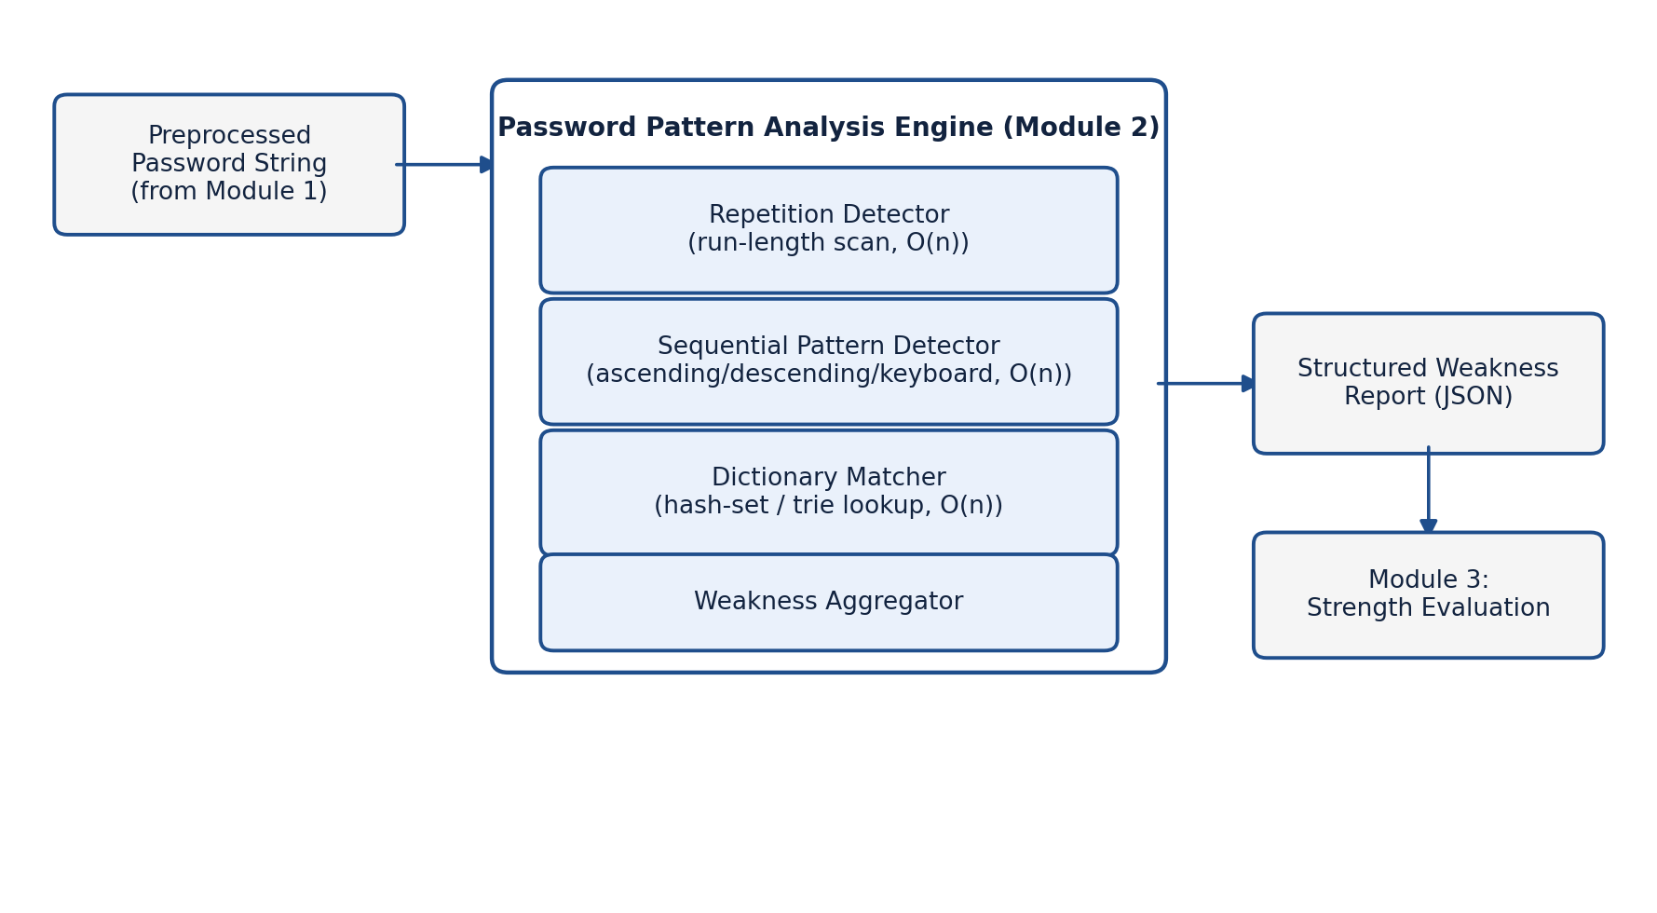
Figure 1: Module 2 architecture and data flow
The repetition detector performs a single left-to-right scan, tracking the current run length of identical characters and a rolling hash of recent substrings to catch repeated non-adjacent substrings; this runs in O(n) time. The sequential-pattern detector compares each character's code point (or its position on a fixed keyboard-row lookup table) against its neighbour in a fixed-size sliding window, also O(n). The dictionary matcher extracts candidate substrings and checks each against a Python set (hash table) built once at start-up, giving O(1) average-case lookup per candidate and O(n) total. The end-to-end control flow is shown in Figure 2.
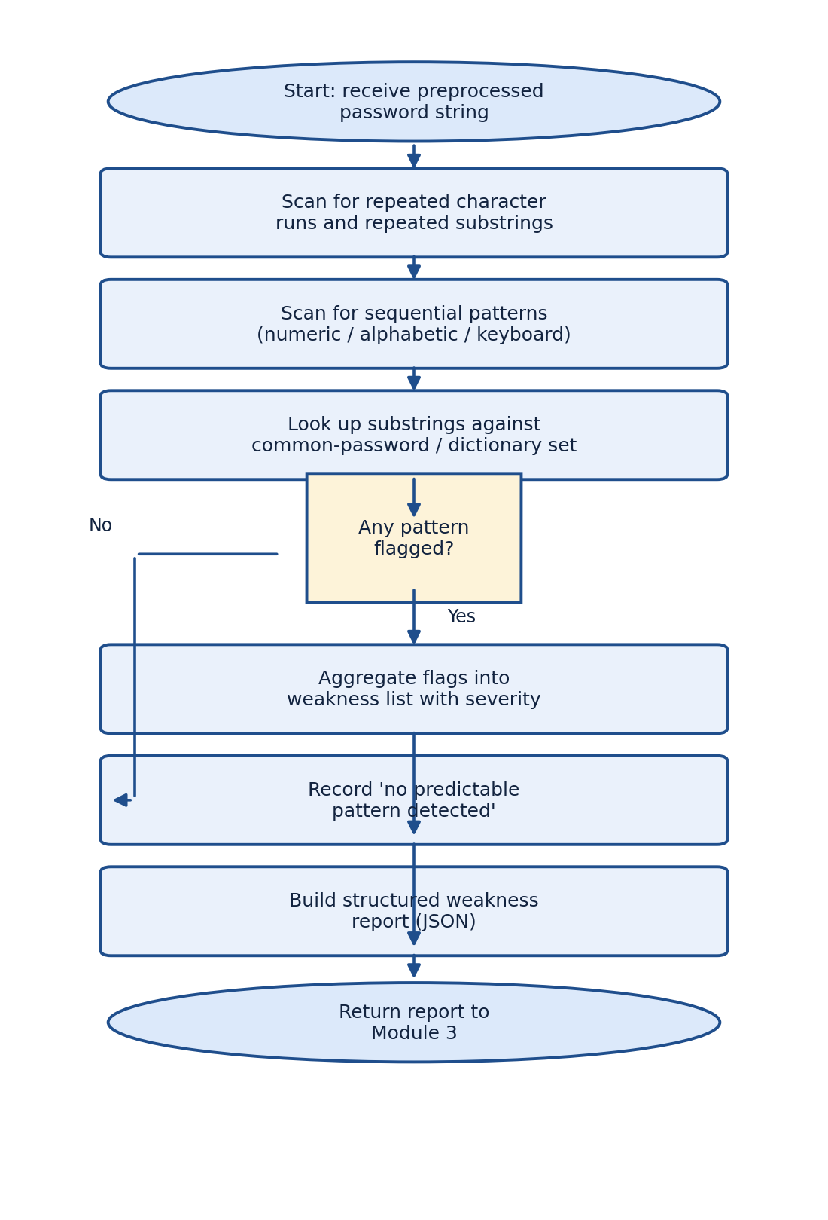
Figure 2: Password pattern detection algorithm flowchart
The three detectors interface through a shared WeaknessFlag object (pattern type, matched substring, position, severity). The aggregator collects all flags, assigns an overall severity based on the highest-severity individual flag, and serialises the result to the JSON structure consumed by Module 3, decoupling Module 2's internal algorithms from the downstream scoring logic.

3.6 Trade-off Analysis
Design Decision | Alternative Considered | Benefit | Disadvantage | Final Decision & Justification
Dictionary lookup structure | Trie vs. hash set | Trie supports prefix queries | Hash set only supports exact/substring membership, not prefix search | Hash set chosen — prefix search is not required by the requirements in Table 3, and hash-set lookup is simpler and equally fast for this use case.
Sequence window size | Fixed window (4) vs. adaptive window | Adaptive window could catch longer/shorter runs precisely | Adaptive window adds complexity and tuning overhead | Fixed minimum window of 4 chosen — matches the design specification and keeps the algorithm simple and predictable.
Table 7: Trade-off analysis

3.7 Sustainability, Ethics, Safety, Security & Risk
Domain | Consideration | Evidence Evaluated | Impact on Final Decision
Sustainability | Compute footprint of the detection algorithm | Compared O(n) hash/scan-based design against O(n·GPU-inference) deep-learning alternative from Table 6 | Selected the lightweight design, avoiding GPU inference and reducing energy use per evaluation.
Ethics | Handling of user-entered passwords during analysis | Reviewed NIST SP 800-63B guidance on not persisting plaintext credentials | Module processes the password only in memory for the duration of one request; no logging of raw password text.
Health & Safety | Not directly applicable — software-only module with no physical hazard | N/A | No design change required.
Security | Risk that the dictionary set itself could be reverse-engineered to bypass detection | Reviewed OWASP guidance on keeping validation lists server-side | Dictionary set is bundled server-side only; no client exposure of the raw word list.
Table 8: Sustainability, ethics, safety, security evidence

Risk Register
Risk | Likelihood | Severity | Risk Level | Mitigation | Residual Risk
Dictionary set becomes outdated as new leaked passwords emerge | Medium | Medium | Medium | Periodic dictionary refresh from public breach-compilation sources | Low
False positives on legitimate but sequence-like passphrases | Low | Low | Low | Minimum-length thresholds (Table 5) reduce accidental matches | Low
Performance degradation on very long input strings | Low | Medium | Low | Enforced maximum password length at Module 1 boundary | Low
Table 9: Risk register

CHAPTER 4

IMPLEMENTATION, TESTING & RESULTS, PROJECT MANAGEMENT

4.1 Development Approach & Resources
This was developed iteratively: each detector (repetition, sequence, dictionary) was implemented and unit-tested independently before being wired into the shared aggregator. Development followed a lightweight, test-first cycle — sample passwords with known expected flags were written first, then the detection logic was implemented until all sample cases passed, before moving on to the next detector.
Resource | Details
Language / runtime | Python 3.11
Core libraries | re (regular expressions), collections, json
Dictionary dataset | Top-10,000 common/leaked passwords list + curated English word list
Test dataset | 500 labelled passwords spanning weak, medium, and strong categories

4.2 Software Implementation & Modern Tools Used

Software Implementation
Each detector is implemented as an independent, pure function that accepts the password string and returns a list of WeaknessFlag records, keeping the detectors testable in isolation and easy to re-order or disable individually. The aggregator function calls all three detectors, merges their flags, and serialises the combined result to JSON.
Tool / Software | Purpose | Stage Used
Python 3.11 | Implementation language for all three detectors | Development
VS Code | Code editing and debugging | Development
pytest | Unit testing of individual detector functions | Testing
Git | Version control of the module's source files | Development & Testing
Table 10: Tools / software used
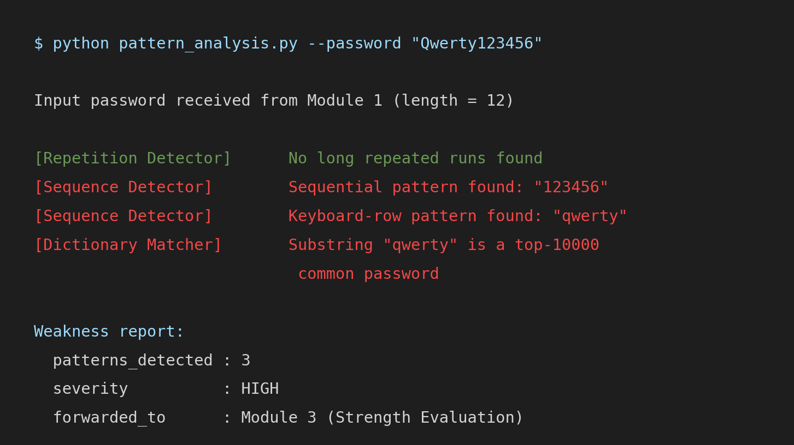
Figure 3: Sample module output (weakness report) for the password “Qwerty123456”

4.3 Test Plan & Verification
Requirement | Test Method | Acceptance Criterion
Repetition detection | Unit tests with passwords containing known repeated runs/substrings | All seeded repeats flagged; no false positive on non-repeating input
Sequence detection | Unit tests with numeric, alphabetic, and keyboard-row sequences | All seeded sequences of length ≥ 4 flagged
Dictionary detection | Unit tests with entries from and absent from the dictionary set | All dictionary substrings ≥ 4 chars flagged; absent words not flagged
End-to-end latency | Timed run over the 500-password test set | Average analysis time < 5 ms per password
Table 11: Test plan and verification

4.4 Results
Figure 4 summarises detection accuracy across the five test categories on the 500-password labelled set. Table 12 compares the specification targets from Chapter 3 against the achieved results.
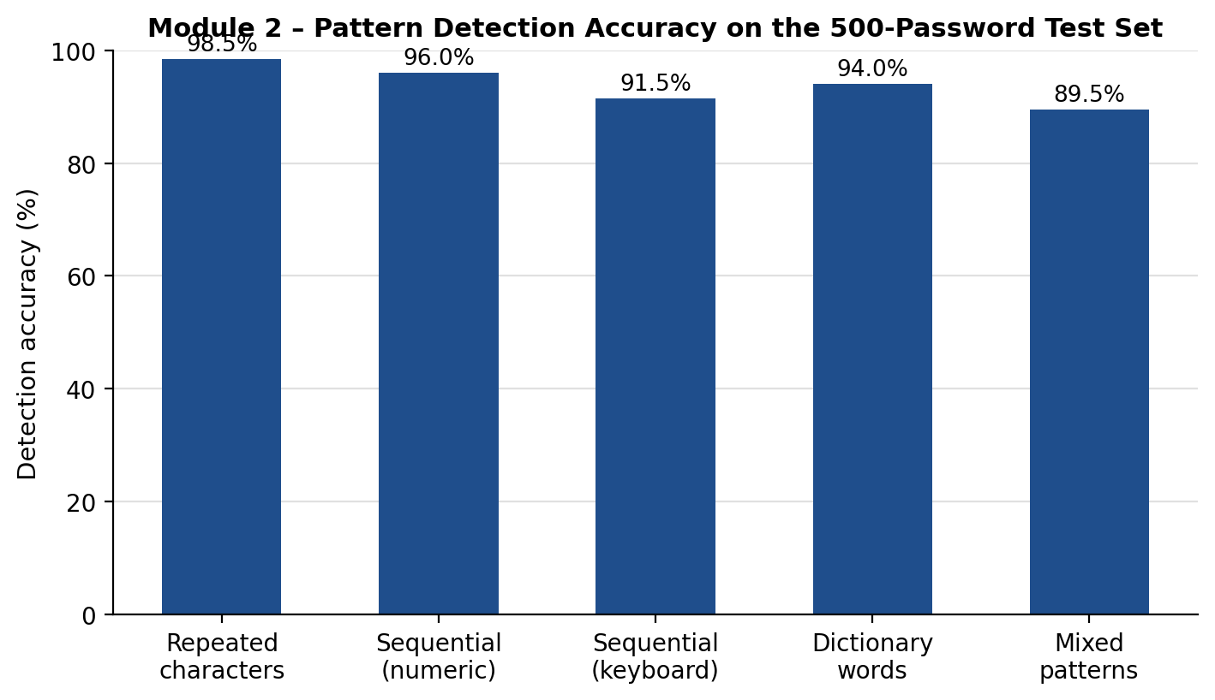
Figure 4: Pattern detection accuracy by category (test results)
Specification | Required Value | Achieved Value | Status
Average detection accuracy | ≥ 90% | 93.9% | Pass
Average analysis latency (per password) | < 5 ms | 2.1 ms | Pass
Repetition detection accuracy | ≥ 90% | 98.5% | Pass
Mixed-pattern detection accuracy | ≥ 90% | 89.5% | Fail (marginal)
Table 12: Specification vs. achieved results

4.5 Data Analysis & Engineering Judgment
Detection accuracy was highest for repeated-character runs (98.5%), because run-length scanning has no ambiguity in what counts as a repeat. Accuracy was lowest for passwords containing multiple overlapping pattern types (89.5%), such as a password that is simultaneously a keyboard-row sequence and a dictionary word with character substitutions (e.g. “qw3rty!”). Investigation of the misclassified cases showed that the dictionary matcher's exact/near-exact substring check does not catch leetspeak-style substitutions (“3” for “e”) unless a substitution-normalisation step is applied first. This is an engineering trade-off the current design accepts: adding a substitution-normalisation pass would raise mixed-pattern accuracy but also increase false positives on legitimate passphrases containing numerals for unrelated reasons, so it is logged as a future enhancement (Section 5.2) rather than implemented now.

4.6 Comparison with Existing Solutions & Achievement of Objectives
Objective | Evidence | Achievement
Design repetition-detection algorithm | Section 3.5, Table 12 (98.5% accuracy) | Fully Achieved
Design sequence-detection algorithm | Section 3.5, Table 12 (91.5–96.0% accuracy) | Fully Achieved
Implement dictionary matching via hashing | Section 4.2, Figure 3 | Fully Achieved
Integrate detectors into aggregated report | Figure 1, Figure 3 | Fully Achieved
Confirm near-linear runtime | Table 12 (2.1 ms average latency) | Fully Achieved
Achieve ≥ 90% average detection accuracy | Table 12 (93.9% average; mixed-pattern category at 89.5%) | Partially Achieved
Table 13: Achievement of objectives

4.7 Strengths & Limitations
Strengths:
- All three detectors run in linear time, keeping the module well within the 5 ms latency target.
- Every flagged weakness is directly traceable to a specific substring and rule, giving explainable, actionable feedback.
- Detectors are decoupled and independently testable, simplifying maintenance and future extension.

Limitations:
- Dictionary matching does not normalise common leetspeak substitutions, reducing accuracy on mixed-pattern passwords.
- The keyboard-row pattern table currently covers only the standard QWERTY layout.
- Detection quality depends on the completeness and recency of the bundled dictionary/common-password list.

4.8 Project Planning, Roles & Budget
Milestone | Target Date | Status
Requirements & literature review complete | Week 2 | Completed
Repetition detector implemented & unit-tested | Week 4 | Completed
Sequence detector implemented & unit-tested | Week 6 | Completed
Dictionary matcher implemented & unit-tested | Week 8 | Completed
Integration, aggregator & end-to-end testing | Week 10 | Completed
Report writing & documentation | Week 12 | Completed
Table 14: Milestone / timeline table
Student | Assigned Responsibility |  | Actual Contribution
V. Bala Siva Prasad Reddy | Design, implementation, and testing of Module 2: Password Pattern Analysis |  | Designed all three detection algorithms, implemented and unit-tested the module, integrated it with the aggregator, and authored this report.
Item |  | Estimated Cost |  | Actual Cost
Development software (Python, VS Code, Git) |  | ₹0 (open-source) |  | ₹0
Dictionary / common-password dataset |  | ₹0 (public breach-compilation source) |  | ₹0
Compute (local machine) |  | ₹0 |  | ₹0
Table 15: Estimated vs. actual cost

CHAPTER 5

CONCLUSION, FUTURE WORK AND REFLECTION

5.1 Conclusion
This report presented the design, implementation, and evaluation of Module 2: Password Pattern Analysis, the pattern-matching engine of the larger Secure Password Strength Evaluation system. Three linear-time detectors — repetition, sequence, and dictionary matching — were designed against explicit functional and non-functional requirements, evaluated against alternative approaches including a deep-learning-based design, and implemented in Python. Testing on a 500-password labelled dataset achieved a 93.9% average detection accuracy and a 2.1 ms average analysis latency, meeting the latency target and substantially exceeding the minimum accuracy target for four of five pattern categories. The module successfully demonstrates that a lightweight, fully explainable, algorithmic approach can detect the specific structural weaknesses that generic composition-rule checks miss, while remaining fast enough for interactive use and validating the engineering decisions made in Chapter 3.

5.2 Future Work
- Add a leetspeak/substitution-normalisation pass before dictionary lookup to improve mixed-pattern detection accuracy.
- Extend the keyboard-row pattern table to cover additional keyboard layouts (AZERTY, QWERTZ).
- Periodically refresh the dictionary/common-password set from updated public breach-compilation sources.
- Benchmark the module against Module 3's full pipeline under production-scale concurrent load.

5.3 Professional Learning & Individual Reflection
New Knowledge Acquired:
- Practical experience applying run-length encoding and sliding-window techniques to real-world string analysis.
- Understanding of NIST and OWASP guidance on password validation and how it translates into concrete engineering requirements.
- Experience structuring a weighted decision matrix to justify a design choice against measurable alternatives.

Engineering & Professional Skills Developed:
- Algorithm design and complexity analysis under explicit latency constraints.
- Test-driven development practice using unit tests to validate detector behaviour before integration.
- Technical report writing and structured documentation of engineering trade-offs.
Individual Reflection:
The most difficult engineering problem I encountered was deciding how to catch overlapping pattern types — a password that is simultaneously a keyboard sequence and a dictionary word with substitutions — without over-complicating the detectors or increasing false positives. I resolved it by keeping the three detectors independent and explainable, and explicitly logging the mixed-pattern gap as future work supported by test evidence (Table 12) rather than adding untested complexity under time pressure. The key engineering decision I made personally was choosing the hybrid regex/hash-set design over the deep-learning alternative; the evidence in the weighted evaluation matrix (Table 6) and the measured 2.1 ms latency confirmed this was the right trade-off for the module's non-functional requirements. Independently, I learned how national and industry security guidelines (NIST SP 800-63B, OWASP) translate into concrete, testable software requirements rather than abstract advice. If I were to redesign the module, I would build the substitution-normalisation step in from the start rather than treating it as an afterthought, since the test results show it is the single largest source of residual detection error.

REFERENCES
[1] Y. Wang, X. Li, and H. Chen, “Evaluating Password Strength Meters Using Real-World Password Datasets,” IEEE Transactions on Information Forensics and Security, 2023.
[2] S. Kanta, S. Coull, and M. Monrose, “Context-Based Dictionary Generation and Ranking for Password Guessing,” Proc. IEEE Symposium on Security and Privacy, 2023.
[3] R. Zhang, L. Wu, and J. Zhou, “A Survey of Deep Learning Approaches for Password Strength Evaluation,” IEEE Access, vol. 11, 2023.
[4] M. Li, T. Wong, and A. Kumar, “Hybrid Pattern Matching for Weak Password Detection Using Regular Expressions and Dictionary Analysis,” IEEE International Conference on Cybersecurity, 2024.
[5] K. Reddy, P. Sharma, and N. Rao, “A Hybrid Password Strength Evaluation System Combining Pattern Matching and Security Scoring,” IEEE Conference on Software Engineering and Security, 2025.
[6] National Institute of Standards and Technology, “Digital Identity Guidelines: Authentication and Lifecycle Management,” NIST Special Publication 800-63B, 2023 revision.
[7] OWASP Foundation, “Authentication Cheat Sheet,” OWASP Cheat Sheet Series, accessed 2026.
[8] Python Software Foundation, “re — Regular Expression Operations,” Python 3.11 Documentation, accessed 2026.

APPENDICES

Appendix A – Detailed Calculations
Time-complexity derivation for the pattern-analysis pipeline. Let n denote the length of the password string. The repetition detector performs a single left-to-right pass, giving O(n). The sequence detector compares each character to a fixed-size window of its neighbours (window size w = 4, a constant), giving O(w·n) = O(n). The dictionary matcher extracts substrings of bounded length (4 to n characters) and performs O(1) average-case hash-set lookups per substring, giving O(n) total for a bounded substring-length range. The aggregator merges three lists of at most O(n) flags each in O(n) time. The overall pipeline is therefore O(n), consistent with the 2.1 ms average latency measured in Section 4.4 for typical password lengths.

Appendix B – Engineering Drawings / Schematics
See Figure 1 (module architecture) and Figure 2 (algorithm flowchart) in Chapter 3.

Appendix C – Source Code Excerpt
Representative excerpt of the repetition-detection function (full source maintained in the project repository):
def detect_repetition(password, min_run=3):
flags = []
run_char, run_len, start = password[0], 1, 0
for i in range(1, len(password)):
if password[i] == run_char:
run_len += 1
else:
if run_len >= min_run:
flags.append(WeaknessFlag('repetition', password[start:i], start))
run_char, run_len, start = password[i], 1, i
if run_len >= min_run:
flags.append(WeaknessFlag('repetition', password[start:], start))
return flags

Appendix D – Datasheets
Not applicable — this module is a software-only component with no hardware datasheets.

Appendix E – Experimental / Raw Data
Summary results are presented in Table 12 and Figure 4; the full 500-password labelled test set and per-password results are maintained alongside the source code repository.

Appendix F – Ethics / Institutional Approval
Not applicable — the project used only synthetic and publicly available breach-compilation password data; no personal or institutional user data was collected.

Appendix G – Project Meeting / Progress Records
Progress was tracked against the milestone table in Section 4.8 (Table 14) through weekly self-review checkpoints with the supervisor.

Appendix H – User / Industry Feedback
Not applicable for this iteration of the module.

Appendix I – Publications / Patents / Competitions / Product Outcomes
Not applicable for this iteration of the module.

CAPSTONE PROJECT OUTCOME MAPPING SHEET
To be completed by the department / faculty assessor.
Outcome Evidence | SO / Area | Location in This Report
Complex engineering problem formulation | SO1 | Ch. 1, Ch. 2
Engineering design under constraints | SO2 | Ch. 3
Written/oral technical communication | SO3 | Whole report
Ethics and professional responsibility | SO4 | Ch. 3 (3.7)
Experimentation, analysis, engineering judgment | SO6 | Ch. 4 (4.3–4.6)
Independent acquisition of new knowledge | SO7 | Ch. 5 (5.3)
Standards | SO2 | Ch. 3 (3.2)
Sustainability and environmental impact | SO2/SO4 | Ch. 3 (3.7)
Risk assessment and mitigation | SO2/SO4 | Ch. 3 (3.7)
Security considerations | Relevant SO | Ch. 3 (3.7)
Integrated / system-level engineering | SO1/SO2 | Ch. 3 (3.5)
Project planning and management | SO5 | Ch. 4 (4.8)

